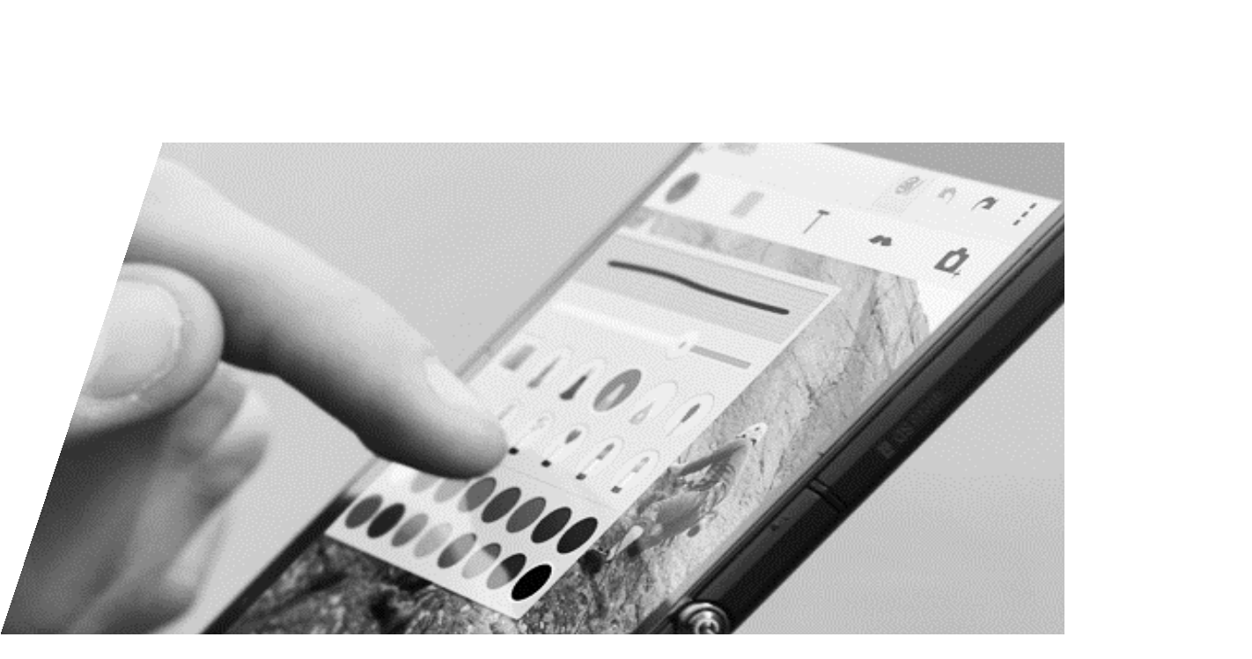MARJ GROUP

GRADE IT!: Grading System

MOBILE APPLICATION
PLAN FOR THE ILS

MEMBERS:

Cortez, Alyssa Nicole Jose, Maica Trishia Orlina Junella Denise Sangalang, Raizen John
1. Introduction

GradeIt the grading system for all teacher of the Values Education Department of Angeles City National High School. This grading system is a new component in their Department and it will be the way of recording of the grade of the student because of the new technology that have been made by Developers

This research aims to complete and to enhance the Android Project of the

Developers to ensure the structure, user interface and functionality of the Application

that will be made. This research paper is not only about the details of the Application but also how it is made and what are the things to be consider

This grading system is implemented as an Android Application that runs in every Android Phone. In addition, this Grading System is important to secure and to manage the grades of every student in a specific subject. This Grading System makes a work convenient and easy to record the grade of a student.

1.1 Background of the Study

The Programmer’s Project decision is influenced by their lead team Programmer Mr. Sangalang wherein he want to dedicate and offer the project for his alma mater and to his beloved Values Education teacher Mrs. Rheamay T. Paras. The reason why the programmer wants to choose this kind of project or system is that because they want to improve the grading system in an updated and latest technology in the 21st Century age of
learning in The Angeles City National High (the company)

The ground cause of the system is that the Angeles City National High School has a system that they record their grades manually in their Log Book or Record Book to keep the grades but the programmers/researchers found out that this kind of system can cause a too much time of transferring the grades to the Worksheet Software. The Programmers decided to make a new handy grade recorder and that can be used to record easily and not manually in their record book.

GRADE BOOK RECORDER
20
10
3

R E C O R D B O O K S P C U S E R S M O B I L E A P P L I C A T I O N

This graph shows the record book user, mobile application user and PC user
20

GADGETS OF THE TEACHERS
10
3
6

A N D R O I D A P P U S E R S
10
I P H O N E U S E R S P C U S E R S I P A D T A B L E T P C A N D R O I D T A B L E T

This graph shows different number of gadget user in the department t of values education in Angeles City National High School
2

This graph shows that there are lot of Android User, but it is not lean into the number of mobile application user to use as a grade recorder. There are lot of Mobile Gadget user, but they didn’t use as a grade recorder. So that’s why the programmer takes the opportunity to do this kind of problem and it is base from survey

1.2 Statement of the Problem

The Values Education Department of Angeles City National High School faces a lot of problems when it comes to their recording system. Such as lost of Paper Copy of the grade of the Student. The fading of the inks in a paper. The tampering which cause of the anomalies and wrong grade computations. In addition, that they face is that the lack of security because there are lot of case that a student can thief the record book of a teacher and they can change it or they can dispose it. The Angeles City National High School issued last 2016 because of the lack of security and awareness to the grade of their student

1.3 Objectives

The programmers’ objective in their System is to create a new Handy and convenient application that is using to record a grade, secure the grade and easy to access to each and every one.

This android application will help other departments and other school also in providing the security efficiency of the grades truly that the grades is matter, and it is important to ensure the safety and security of the grades. Morally speaking Grades are the reflection of your personality and habits. In addition to the objective of this program is that to ensure the fastest and convenient way of managing the grades

1.4 Scope

The Function of the System is that this system can record and keep the grade with a specific user and it can be register by the office of teaching in the department of the main campus. The System is must be also user friendly. This application has also customization in grading the grades. They can input a specific percentage of a grade. They can also add some field to fill and add a grade.

1.5 Limitation

The limitation of this system is that the system cannot Add images to specify the face of a student. The Grading System cannot change the grade of a student Subjectively. This Grading System is not a person to change the grade of a student this grading system is an input and output system wherein you will put the grade then it will compute for you objectively and just
2. Background of the Local

2.1 History of the Company

In 1968, one of the philanthropists of the city, known as the Henson-Suarez Enterprises donated the 60,000 square meter lot at the Arayat Boulevard of the City Government, which was intended for an educational institution. On February 29 of the same year, the Sangguniang Panglunsod held their 18th Regular Session and their priority agenda was RESOLUTUION NO. 130 which was sponsored by councilors Abad Santos, Roman, Nepomuceno, Sandico and Arcilla. This resolution was then approved by the ex-mayor Rafael del Rosario. The primary and ultimate objective of this high school is to provide secondary education to poor but deserving students coming from the different sectors of Angeles City. The City Government, together with those people who exerted efforts and time for the establishment of Angeles City High School believed that any education enterprise should produce disciplined, functional and desirable citizens of the land.

The school was refunded by City Government and was nationalized through the issuance of Executive Oder No. 189 by the encumber President Corazon C. Aquino 1998. Today, the school is operating into two sites: the main office in Pampang and the other at the Citizenter, Pandan both in Angeles City with population getting bigger year after year. The school curricular offering is centered on the New Secondary Education Curriculum (NSEC) OF Secondary Education Development Program (SEDP). The school is also offering Special Science Classes under the Department Of Science and Technology (DOST).

2.2 Current State of the Technology

Their Computer is operated by Windows PC (Windows 7 Ultimate and other Version of Windows). They use also record books and papers. They use also notebooks and record slips to take the record. They have also File Systems with lock to ensure and keep the security.

3. GradeIt! (The New Grading System App)

This GradeIt is operated by any Android OS (KitKat and above). It can be operated in a 256MB Random Access Memory. It can consume 50MB of Storage area. This application is easy to use and the concept of User Interface is based from the latest and updated UI and UX (user experience). This concept is basically based from the IT Industry and the app is inspired from the most voted and trusted application in the Google Play Store.

This grading system has a log in activity and registration activity. The user of this application is the teacher. The user can add, update and delete student. It can add, delete and update the grading concept of the application. This application has also security to ensure the safeties of the grades.

The advantage of this system is that it ensures the synchronization of the data. It ensures the security and it ensures the management of the information. It also provides the organize system and data security and good mathematical computation of algorithms

4. Project Journal

4.1 Summary

The Group of Developers made their day to complete the tasks of each

and every one. Every session of research has a problem to be encounter. Every moment there is a failure to fix. Everything must be organized and well with the flow of the work

4.2 Alyssa Nicole Cortez

The Group session makes all things memorable and all things must be on focus to the project the summary of thing that we have learned and the task that we have. From Planning to Drafting to correction until we find the thing that fits on the program
4.3 Junella Denise Orlina

In Group Activity projects we ensure that our knowledge is to continuously expose, and we continue in learning something. In our Coding session in the part of designing we always explore the attributes and the things that the can do. We do always research about the latest android applications.

4.3 Maica Trishia Jose

In functionality we always do an experiments and testing about the easy and logical way to ensure that the functionality of an application is working. Every session we do some research on how to Improve and maintain our work. The work that we dedicate is important to ensure the experience of the user.

4.4 Raizen Sangalang

We conduct research and interview with my group works. As I do an interview with the company we ensure that the data are always correct and well review. This part of researching is the foundation of the content of the system or the application itself. It is difficult to enhance the capability of an application without an update and well maintained
Bibliography
Obsanjo, D. (2017). W3C XML. Retrieved from MSDN Microsoft: https://msdn.microsoft.com/en- us/library/aa468564.aspx

Perg, D. (n.d.). Beginning Programming: Designing a Program. Retrieved from InformIT:
http://www.informit.com/articles/article.aspx?p=25074&seqNum=4

Program Development Life Cycle. (n.d.). Retrieved from BTECH :
http://btechsmartclass.com/CP/program-development.htm

TutorialsPoint. (2015). Android Programming.

TutorialsPoint. (2016). Java Programming .

